Customer Shopping Behavior Analysis

A Comprehensive Data Analysis Report

Prepared by: Avi Shah

1. Project Overview
This project examines customer shopping behavior using transactional data covering 3,900 purchase records spanning multiple product categories. The primary objective is to derive actionable insights into spending patterns, customer demographics, product preferences, discount behavior, and subscription trends — all aimed at informing data-driven business strategies.
2. Dataset Summary
The dataset comprises the following structure:
- Total Records: 3,900
- Total Columns: 18
- Missing Data: 37 missing values in the Review Rating column

Key Features
- Customer Demographics – Age, Gender, Location, Subscription Status
- Purchase Details – Item Purchased, Category, Purchase Amount (USD), Season, Size, Color
- Shopping Behavior – Discount Applied, Previous Purchases, Frequency of Purchases, Review Rating, Shipping Type
3. Exploratory Data Analysis (Python)
Data preparation and cleaning were performed in Python using the pandas library. The following steps were carried out systematically before loading data for SQL analysis.
- Data Loading – The dataset was imported using pandas, enabling efficient in-memory manipulation of all 3,900 rows.
- Initial Exploration – Used df.info() to inspect column types and null counts, and .describe() to generate summary statistics across all numeric fields.
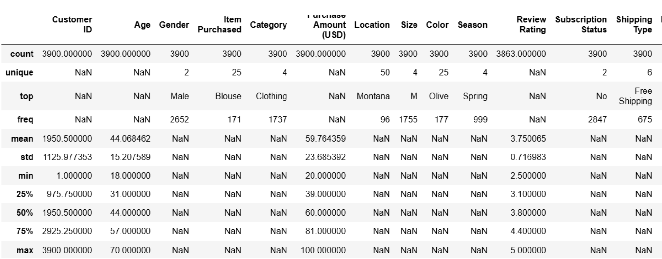
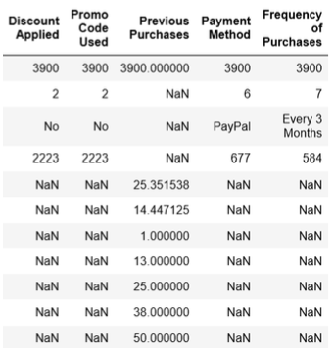
- Missing Data Handling – Identified 37 missing values in the Review Rating column. These were imputed using the median rating computed per product category, preserving category-level rating distributions.
- Column Standardization – All column names were renamed to snake_case format for consistency, readability, and compatibility with SQL systems.
- Feature Engineering – Two new derived columns were created: age_group (customer age bins for segmentation) and purchase_frequency_days (derived from purchase frequency labels).
- Data Consistency Check – Confirmed that discount_applied and promo_code_used were redundant columns. promo_code_used was dropped to eliminate duplication.
- Database Integration – The cleaned DataFrame was exported to a PostgreSQL database via a Python script, enabling structured SQL-based analysis.
4. Data Analysis using SQL (Business Transactions)
Structured queries were executed in PostgreSQL to answer ten key business questions. The findings are presented below with supporting data tables.
4.1 Revenue by Gender
Total revenue was compared across customer gender groups to understand purchasing contribution.
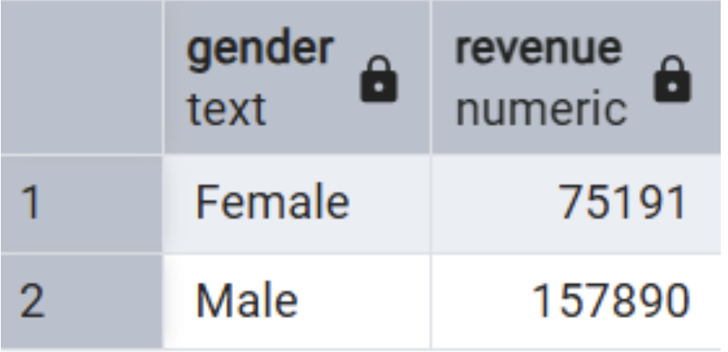
Male customers contributed approximately 2× the revenue of female customers, accounting for the larger portion of the customer base in this dataset.
4.2 High-Spending Discount Users
Customers who applied discounts yet still spent above the average purchase amount were isolated. A total of 839 such customers were identified, indicating strong engagement even without full-price deterrence.
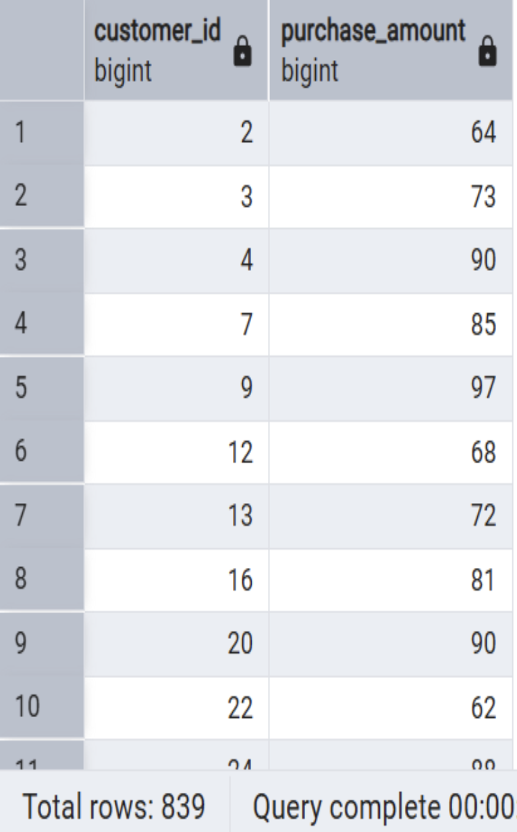
4.3 Top 5 Products by Average Review Rating
Products were ranked by their average customer review rating.
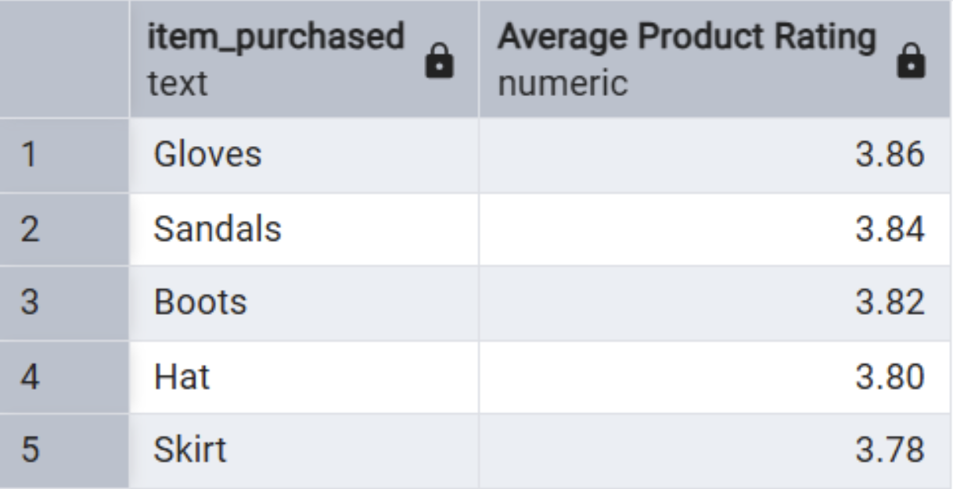
4.4 Shipping Type Comparison
Average purchase amounts were compared between Standard and Express shipping options.
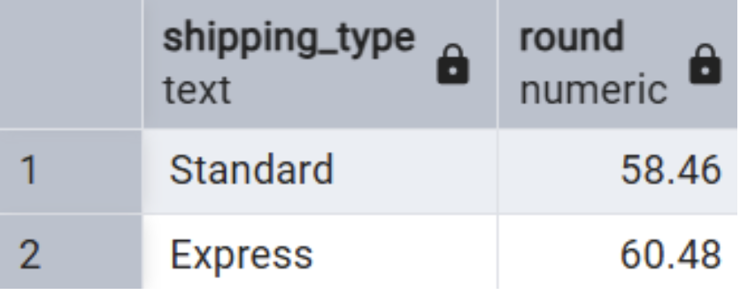
Customers opting for Express shipping tend to spend slightly more per transaction, suggesting a correlation between urgency, intent, and purchase value.
4.5 Subscribers vs. Non-Subscribers
Subscription status was analyzed in relation to average spend and total revenue.
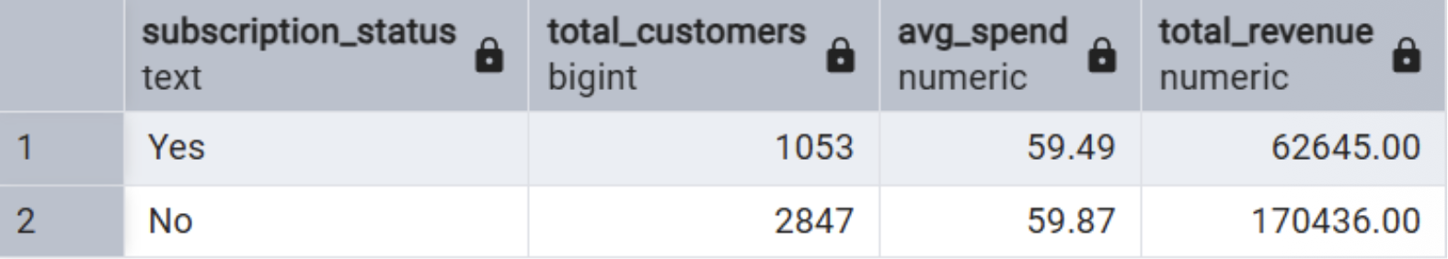
While non-subscribers far outnumber subscribers, the average spend per transaction is nearly identical across both groups — suggesting subscription status alone does not drive higher spending per visit.
4.6 Discount-Dependent Products
The five products with the highest proportion of discounted purchases were identified.
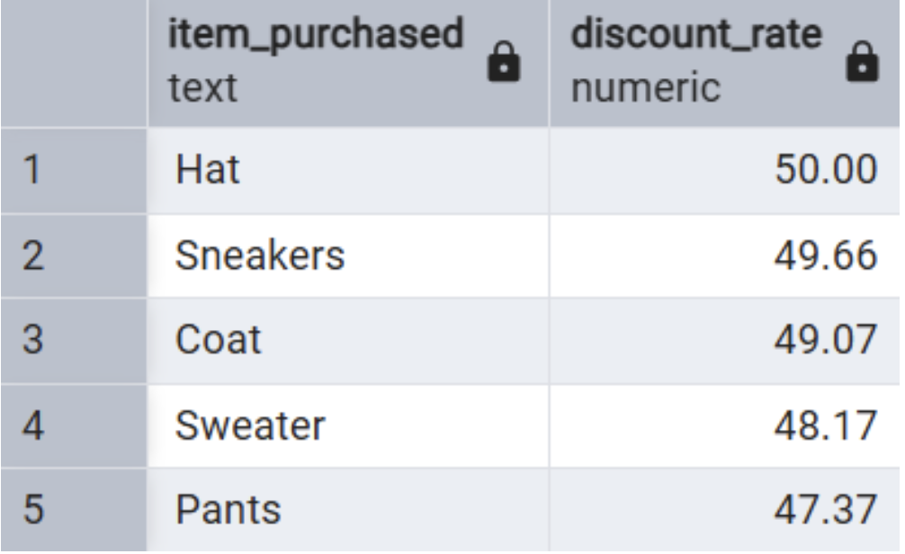
4.7 Customer Segmentation
Customers were classified into three segments based on purchase history volume.
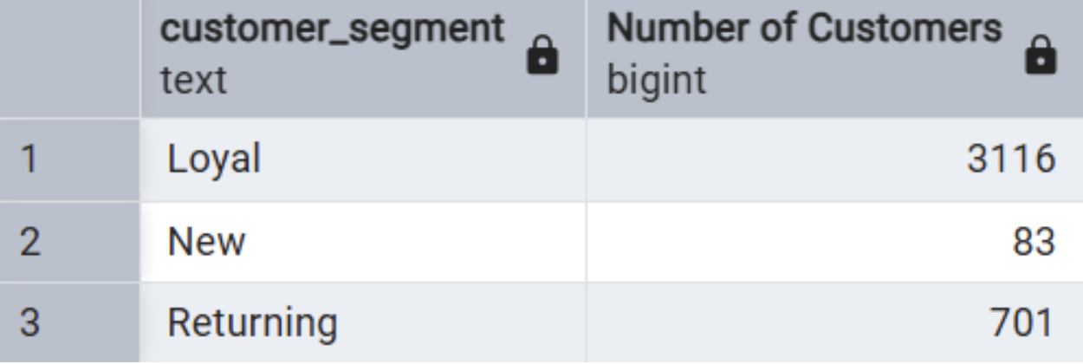
The dataset is overwhelmingly composed of Loyal customers (80%), reflecting a stable and repeat-buying customer base.
4.8 Top 3 Products per Category
The most frequently purchased items within each product category were ranked.
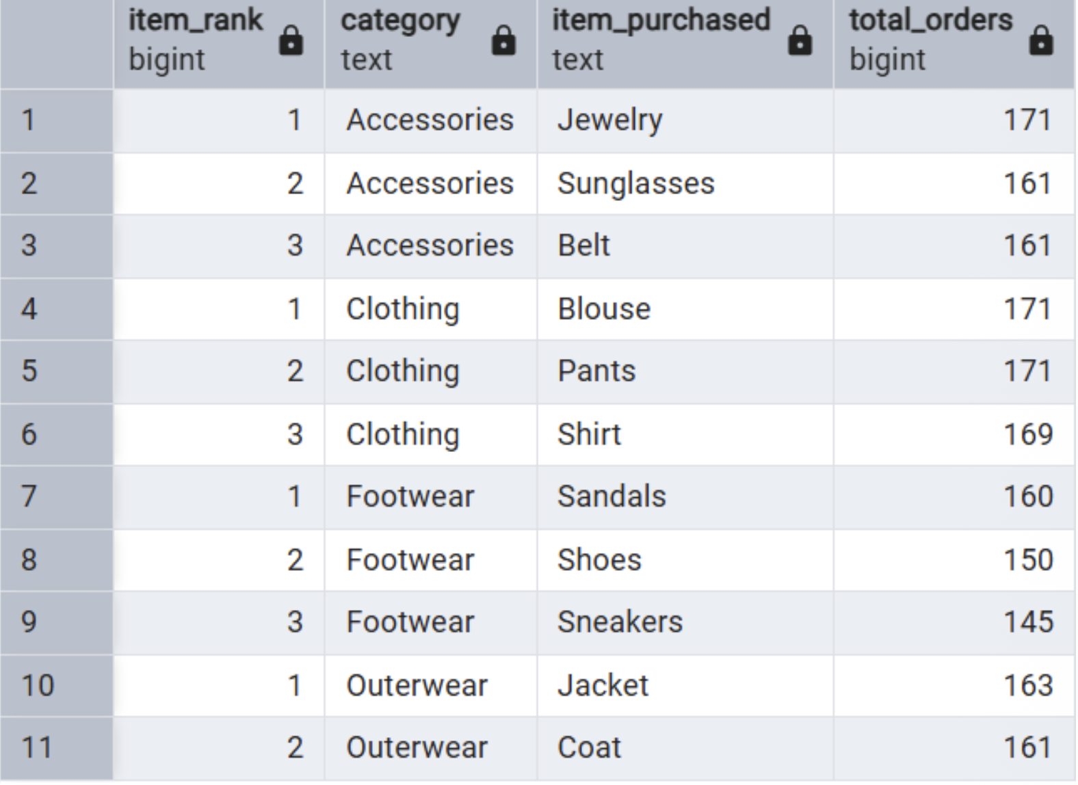
4.9 Repeat Buyers & Subscription Likelihood
Customers with more than 5 previous purchases were assessed for subscription uptake.
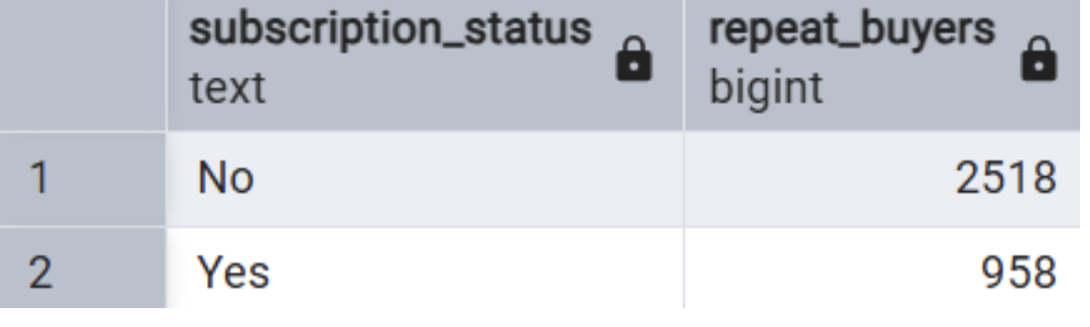
A notable finding: even among repeat buyers, the majority have not subscribed — representing a significant conversion opportunity for targeted subscription campaigns.
4.10 Revenue by Age Group
Total revenue contribution was calculated across four customer age groups.
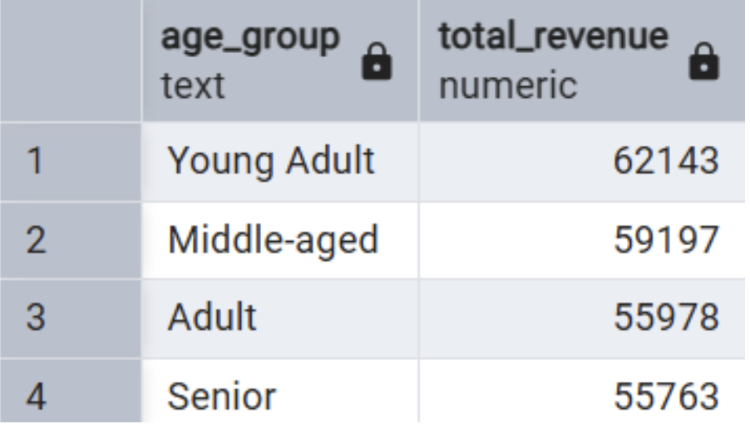
Young Adults lead in revenue generation, closely followed by Middle-aged customers. Revenue is relatively evenly distributed across all age groups, indicating broad market reach.
5. Interactive Dashboard (Power BI)
An interactive Power BI dashboard was developed to visualize the key findings. The dashboard features a dark, aesthetic theme with high-contrast visuals designed for clarity and professional presentation.
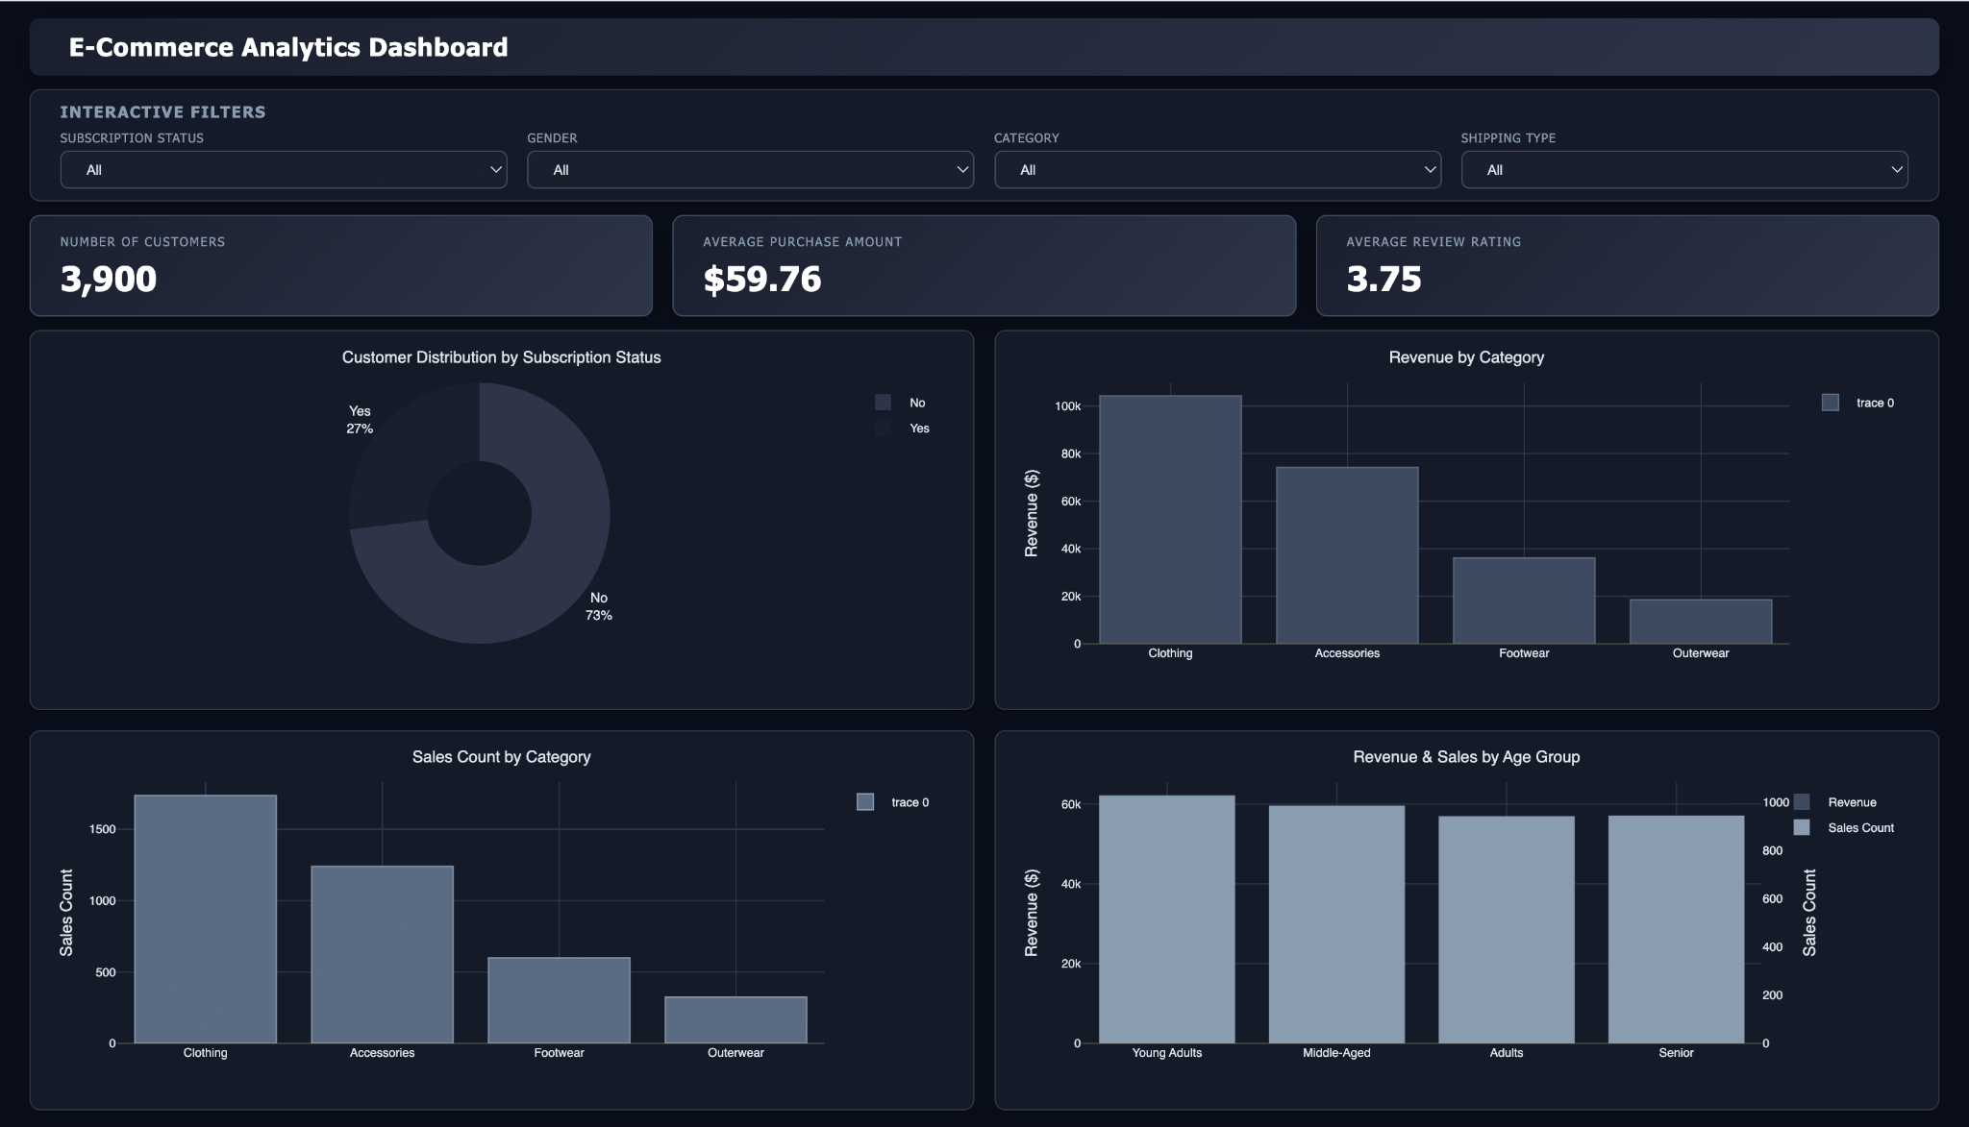
Dashboard Highlights
- KPI Cards – Prominent summary tiles displaying Total Customers (3.9K), Average Purchase Amount ($59.76), and Average Review Rating (3.75).
- Subscription Donut – Donut chart illustrating the subscriber split — 27% subscribed vs. 73% non-subscribed — with dark-mode styling.
- Revenue by Category – Clustered bar chart comparing total revenue across Clothing, Accessories, Footwear, and Outerwear.
- Sales by Category – Separate bar chart showing order volume per category for cross-referencing revenue vs. units sold.
- Revenue by Age Group – Horizontal bar chart ranked from Young Adult to Senior, highlighting the contribution of each demographic.
- Sales by Age Group – Complementary horizontal bar showing purchase count distribution across age groups.
- Slicers / Filters – Interactive filters for Subscription Status, Gender, Category, and Shipping Type enabling drill-down analysis.
6. Business Recommendations
Based on the analytical findings, the following strategic recommendations are proposed:
- Convert Repeat Buyers to Subscribers – With 2,518 high-frequency buyers still unsubscribed, a targeted subscription campaign offering exclusive perks (early access, loyalty discounts) could significantly grow the subscriber base with minimal acquisition cost.
- Reassess Discount Strategy for High-Dependency Products – Items like Hat, Sneakers, and Coat show nearly 50% discount rates. A tiered discount model or value-bundling approach could reduce margin erosion while sustaining demand.
- Double Down on Young Adult Marketing – Young Adults are the top revenue-generating segment. Personalised digital campaigns, social media targeting, and trend-forward product placements can further capture this audience's spending power.
- Leverage Express Shipping as a Premium Offering – Express shipping correlates with slightly higher average spend. Promoting faster shipping tiers as a premium upsell during checkout could lift average order value.
- Spotlight Top-Rated Products in Campaigns – Gloves, Sandals, and Boots top the review ratings. Feature these in homepage banners, email campaigns, and recommendation engines to drive traffic toward high-satisfaction items.
- Grow the New Customer Segment – New customers represent only 83 out of 3,900 — just 2.1% of the base. Investing in acquisition channels (referral programs, onboarding offers) is critical to long-term sustainable growth.
- Optimise Clothing Category Revenue – Clothing leads across both revenue and sales volume. Seasonal capsule collections and size-personalisation features could further deepen engagement in this top-performing category.

